Hover img

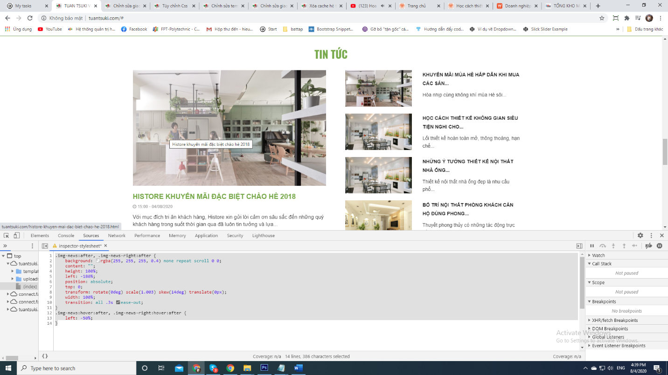

.img-news,.img-news-right{

position: relative;

overflow: hidden;

display: block;

height: 100%;

width: 100%;

}

.img-news:after, .img-news-right:after {

background: rgba(255, 255, 255, 0.4) none repeat scroll 0 0;

content: "";

height: 100%;

left: -180%;

position: absolute;

top: 0;

transform: rotate(0deg) scale(1.003) skew(14deg) translate(0px);

width: 100%;

transition: all .3s ease-out;

}

.img-news:hover:after, .img-news-right:hover:after {

left: -50%;

}

2

.single-banner a:before {

content: "";

position: absolute;

right: 0;

left: 0;

top: 0;

bottom: 0;

-webkit-transition: all 0.6s ease-out 0s;

-moz-transition: all 0.6s ease-out 0s;

transition: all 0.6s ease-out 0s;

}

.single-banner a:after {

content: "";

position: absolute;

right: 0;

left: 0;

top: 0;

bottom: 0;

-webkit-transition: all 0.6s ease-out 0s;

-moz-transition: all 0.6s ease-out 0s;

transition: all 0.6s ease-out 0s;

}

.single-banner a:hover:before {

background-color: rgb(224 250 205 / 33%);

right: 50%;

left: 50%;

}

.single-banner a:hover:after {

background-color: rgb(224 250 205 / 33%);

top: 50%;

bottom: 50%;

}

3. cắt góc

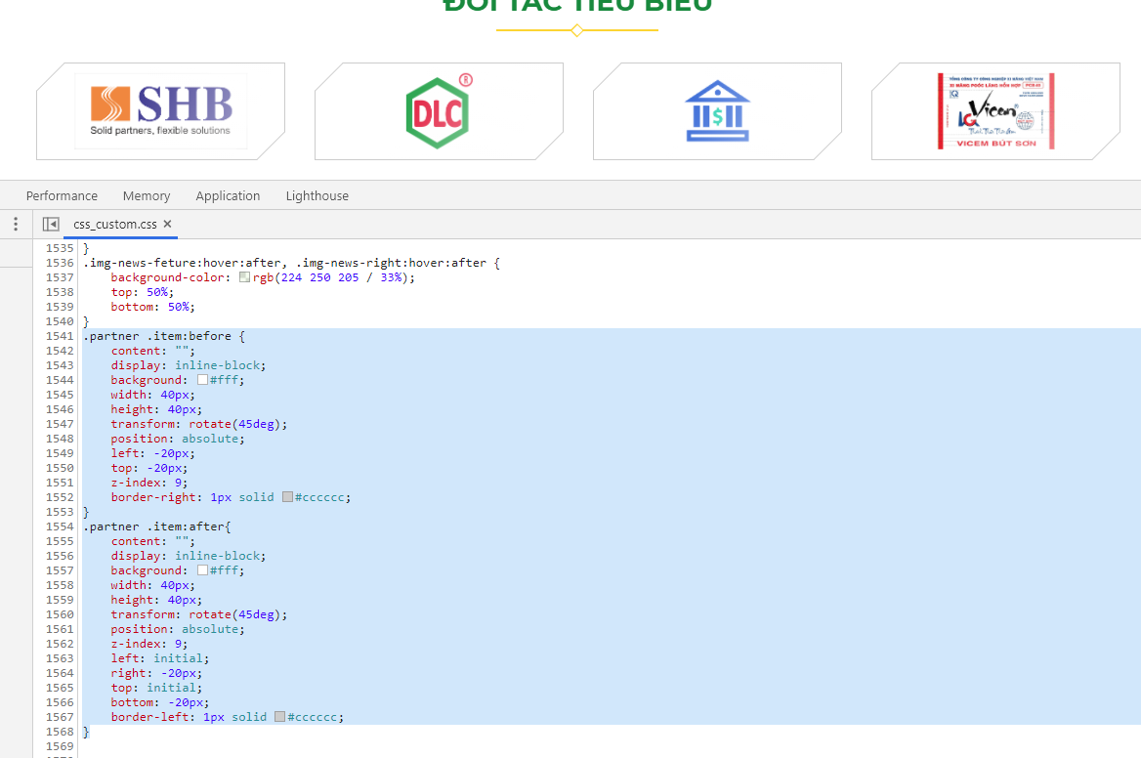

.partner .item:before {

content: "";

display: inline-block;

background: #fff;

width: 40px;

height: 40px;

transform: rotate(45deg);

position: absolute;

left: -20px;

top: -20px;

z-index: 9;

border-right: 1px solid #cccccc;

}

.partner .item:after{

content: "";

display: inline-block;

background: #fff;

width: 40px;

height: 40px;

transform: rotate(45deg);

position: absolute;

z-index: 9;

left: initial;

right: -20px;

top: initial;

bottom: -20px;

border-left: 1px solid #cccccc;

}

4 chéo góc

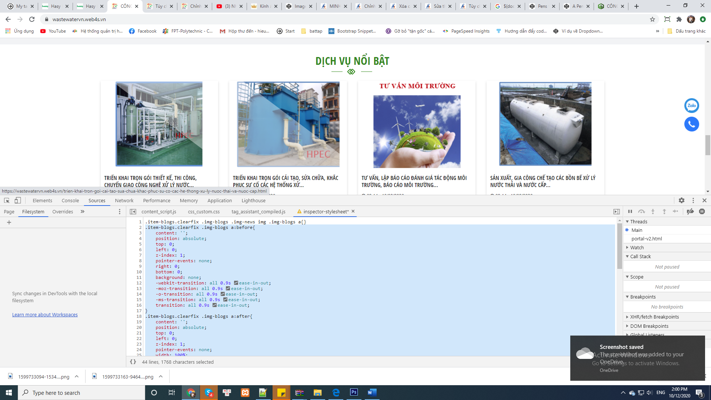

.item-blogs.clearfix .img-blogs a:before{

content: '';

position: absolute;

top: 0;

left: 0;

z-index: 1;

pointer-events: none;

right: 0;

bottom: 0;

background: none;

-webkit-transition: all 0.9s ease-in-out;

-moz-transition: all 0.9s ease-in-out;

-o-transition: all 0.9s ease-in-out;

-ms-transition: all 0.9s ease-in-out;

transition: all 0.9s ease-in-out;

}

.item-blogs.clearfix .img-blogs a:after{

content: '';

position: absolute;

top: 0;

left: 0;

z-index: 1;

pointer-events: none;

width: 100%;

height: 100%;

background: rgb(255 255 255 / 40%);

-webkit-transition: 0.85s ease-in-out;

-moz-transition: 0.85s ease-in-out;

-ms-transition: 0.85s ease-in-out;

-o-transition: 0.85s ease-in-out;

transition: 0.85s ease-in-out;

-webkit-transform: scale3d(2, 1.5, 1) rotate3d(0, 0, 1, 45deg) translate3d(0, -150%, 0);

-moz-transform: scale3d(2, 1.5, 1) rotate3d(0, 0, 1, 45deg) translate3d(0, -150%, 0);

-o-transform: scale3d(2, 1.5, 1) rotate3d(0, 0, 1, 45deg) translate3d(0, -150%, 0);

-ms-transform: scale3d(2, 1.5, 1) rotate3d(0, 0, 1, 45deg) translate3d(0, -150%, 0);

transform: scale3d(2, 1.5, 1) rotate3d(0, 0, 1, 45deg) translate3d(0, -150%, 0);

}

.item-blogs.clearfix .img-blogs a:hover:after {

-webkit-transform: scale3d(2, 1.5, 1) rotate3d(0, 0, 1, 45deg) translate3d(0, 150%, 0);

-moz-transform: scale3d(2, 1.5, 1) rotate3d(0, 0, 1, 45deg) translate3d(0, 150%, 0);

-o-transform: scale3d(2, 1.5, 1) rotate3d(0, 0, 1, 45deg) translate3d(0, 150%, 0);

-ms-transform: scale3d(2, 1.5, 1) rotate3d(0, 0, 1, 45deg) translate3d(0, 150%, 0);

transform: scale3d(2, 1.5, 1) rotate3d(0, 0, 1, 45deg) translate3d(0, 150%, 0);

}



<div class="banner">

<div class="row">

<div class="col-sm-6 col-xs-12">

<div class="img_banner">

<span class="line line-top"></span>

<span class="line line-right"></span>

<span class="line line-bottom"></span>

<span class="line line-left"></span>

<img src="/uploads/plugin/custom_img/2021-04-02/1617357833-648362111-custom.jpg"/>

</div>

</div>

<div class="col-sm-6 col-xs-12">

<div class="img_banner">

<span class="line line-top"></span>

<span class="line line-right"></span>

<span class="line line-bottom"></span>

<span class="line line-left"></span>

<img src="/uploads/plugin/custom_img/2021-04-02/1617357833-82154345-custom.jpg"/>

</div>

</div>

</div>

</div>

/*hover banner*/

.img_banner:hover .line-top {

width: calc(100% - 30px);

}

.img_banner:hover .line-right {

height: calc(100% - 30px);

}

.img_banner:hover .line-bottom {

width: calc(100% - 30px)

}

.img_banner:hover .line-left {

height: calc(100% - 30px)

}

.img_banner .line {

transition: all .4s;

}

.img_banner.line-top {

position: absolute;

top: 15px;

left: 15px;

width: 0;

border-top: 1px solid #fff;

}

.img_banner {

display: block;

position: relative

}

.img_banner .line-top {

position: absolute;

top: 15px;

left: 15px;

width: 0;

border-top: 1px solid #fff

}

.img_banner .line-right {

top: 15px;

right: 15px;

border-left: 1px solid #fff;

height: 0;

position: absolute;

}

.img_banner .line-bottom {

position: absolute;

bottom: 15px;

right: 15px;

left: auto;

width: 0;

border-bottom: 1px solid #fff

}

.img_banner .line-left {

bottom: 15px;

left: 15px;

border-left: 1px solid #fff;

height: 0;

position: absolute

}